# Lab 01a: HTML Basics

Goal of this lab : Understand and practice basic HTML tags.

You will create your own web page by choosing a specific topic. You can use Wikipedia for example to get data about your chosen topic (talk about a technology, a city, a historical event, etc.).

The web page will look like this:

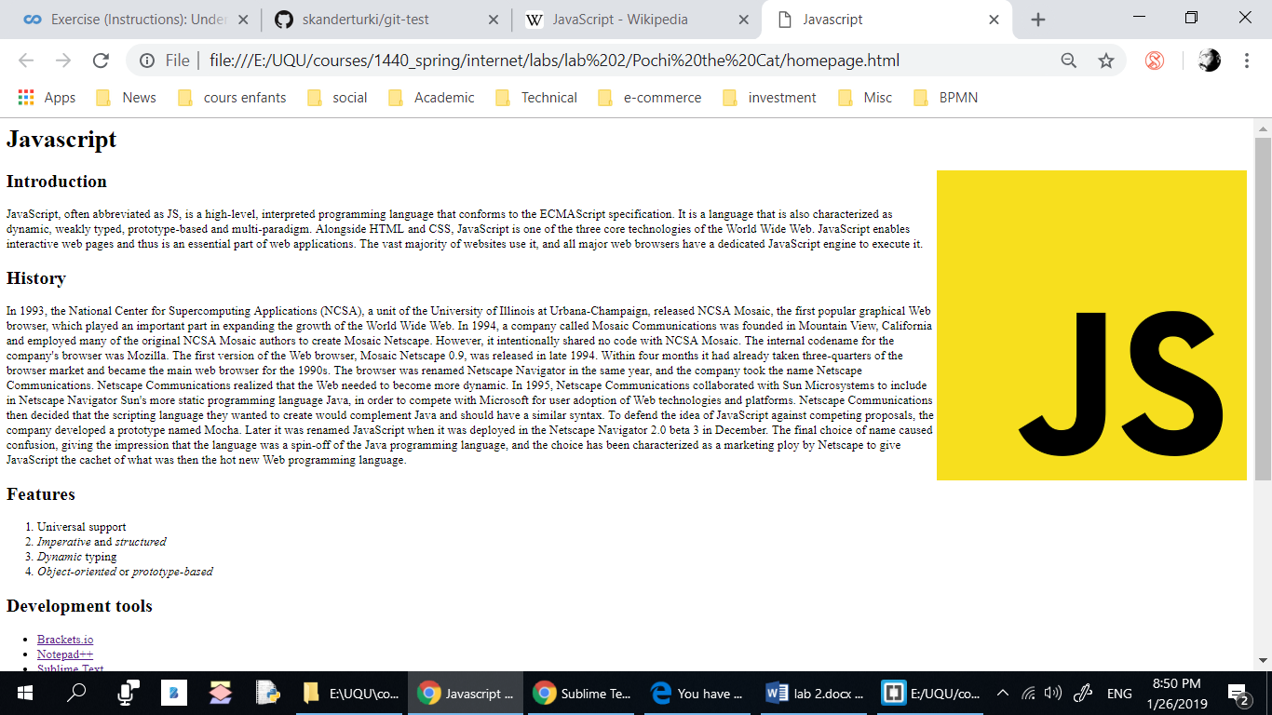

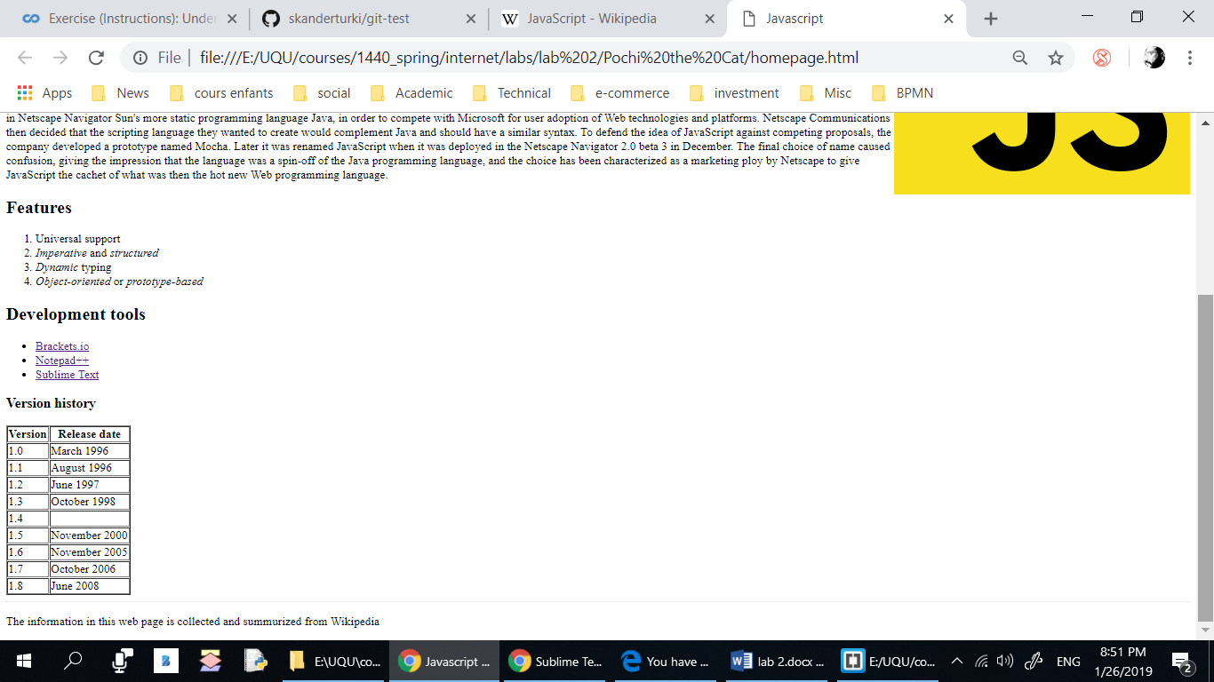

## Development Tool:

Use Visual Studio Code + Google chrome.

## Steps:

1. Create a folder on your Desktop named lab_01.
2. *Start your editor (VSCode).*
3. Create an empty file called index.html.
4. Add the DOCTYPE tag.
5. Start by creating the root **html** tag and specify the language of the page.
6. Add a **head** section and a **body** section. Add a **title** tag (in the head section).
7. Add the page encoding tag.
8. Save your file and check if it is working by opening it in a browser using the “live server” extension (go to file->preferences->extensions to install live server).
9. Add a heading h1 for the page.
10. Add one or more paragraphs of text among the subheadings, making sure to put each of your paragraphs in **p** tags.
11. Add a list under a subheading h2.
12. Add a footer section using the **Footer** tag containing the author name and the date.
13. Find an image on the web and save it to the folder where your web page is saved. Then include the image to your document using the img tag. Image files vary widely in size, so you might find that your image is too large on the page when viewed in a browser. In this case, you can modify its **width** attribute. Do not forget to specify the alt attribute.
14. Use character entities (&lt; and &gt; ) to display this HTML code in the content of the page:

<p>This is a paragraph </p>

End